# **BUSINESS CASE**

## **INX Future Inc Employee Performance**

INX Future Inc, (referred as INX), is one of the leading data analytics and automation solutions provider with over 15 years of global business presence. INX is consistently rated as top 20 best employers past 5 years. INX human resource policies are considered as employee friendly and widely perceived as best practices in the industry.

Recent years, the employee performance indexes are not healthy and this is becoming a growing concern among the top management. There has been increased escalations on service delivery and client satisfaction levels came down by 8 percentage points.

CEO, Mr. Brain, knows the issues but concerned to take any actions in penalizing non-performing employees as this would affect the employee morale of all the employees in general and may further reduce the performance. Also, the market perception best employer and thereby attracting best talents to join the company.

Mr. Brain decided to initiate a data science project, which analyses the current employee data and find the core underlying causes of this performance issues. Mr. Brain, being a data scientist himself, expects the findings of this project will help him to take right course of actions. He also expects the clear indicators of non-performing employees, so that any penalization of non-performing employee, if required, may not significantly affect other employee morals.

# **PROJECT OVERVIEW:**

The goal of this project is to analyse employee performance within the organization and develop predictive models to enhance hiring processes and improve overall performance.

**The project will focus on four key objectives:**

1. Department-wise Performances Analysis:

2. Identification of Top 3 Important Factors Affecting Employee Performance:

3. A trained model which can predict the employee performance based on factors as inputs. This will be used to hire employees

4. Recommendations for Performance Improvement

## **Problem Statement:**

* The organization faces challenges in accurately assessing employee performance, leading to inefficiencies in hiring processes and suboptimal workforce productivity.
* To address these challenges, the aim is to develop a data science project which identifies the root causes of declining employee performance indices at INX Future Inc. and provide clear indicators for non-performing employees without negatively impacting overall employee morale or the company's reputation as a top employer.

# **DOMAIN ANALYSIS:**

**Employee Demographics**:

Includes **EmpNumber**, **Age**, **Gender**, **EducationBackground**, **MaritalStatus**. These fields help in understanding the diversity and background of the workforce.

**Departmental Data**:

**EmpDepartment** and **EmpJobRole** indicate the department and specific roles of the employees, crucial for analysing department-specific performance.

**Work-related Details:**

**BusinessTravelFrequency** and **DistanceFromHome** could affect employee satisfaction and performance.

**EmpEducationLevel**, **EmpEnvironmentSatisfaction**, **EmpHourlyRate**, **EmpJobInvolvement, EmpJobLevel, EmpJobSatisfaction** provide insights into the educational background and job satisfaction levels which are directly linked to performance.

**Performance Metrics:**

**PerformanceRating** is the key outcome variable. Other related metrics include **YearsSinceLastPromotion, YearsWithCurrManager, and ExperienceYearsAtThisCompany,** which help in understanding career progression and its impact on performance.

**Additional Attributes:**

**OverTime** and **Attrition** indicate work-life balance and employee retention, respectively, which are critical for organizational health.

# **ANALYSIS METHODOLOGY**

Both visual analysis and statistical methods are carried out for data exploration.

## **Visual analysis methods:**

* Univariate analysis
* Bivariate analysis
* Multivariate analysis

## **Statistical methods used:**

* Correlation coefficient

## **Insights driven from the analysis:**

* **Gender**: The distribution of performance ratings across genders can reveal if there is a gender bias in performance evaluations.
* **EducationBackground**: Understanding how employees from different educational backgrounds are rated can help in assessing if educational diversity impacts performance perceptions.
* **MaritalStatus**: This plot can show if marital status influences stability and performance ratings, potentially indicating if personal life stability translates into professional performance.
* **EmpDepartment**: Different departments might have varying benchmarks for performance ratings. This plot helps in identifying if certain departments rate their employees more stringently or leniently.
* **EmpJobRole**: Similar to departments, this can show if specific job roles are associated with higher or lower performance ratings, which might reflect on the expectations and pressures associated with those roles.
* **BusinessTravelFrequency**: Employees who travel more or less frequently might experience different stress levels and work challenges, which could affect their performance ratings.
* **EmpEducationLevel**, **EmpEnvironmentSatisfaction**, **EmpJobInvolvement**, **EmpJobLevel**, **EmpJobSatisfaction**: These plots can highlight how intrinsic job factors and personal employee satisfaction levels correlate with performance ratings.
* **NumCompaniesWorked**: Insights from this plot can indicate if having experience in multiple companies affects performance positively or negatively.
* **OverTime**: Overworking can either be seen as a sign of dedication or a route to burnout. This plot can help understand how overtime is affecting employee performance ratings.
* **EmpLastSalaryHikePercent**: This could show if salary hikes are aligned with performance ratings, potentially indicating if financial rewards are being used effectively as a motivational tool.
* **EmpRelationshipSatisfaction**, **TrainingTimesLastYear**, **EmpWorkLifeBalance**: These factors contribute to an employee's overall work satisfaction and could directly impact their performance ratings.
* **ExperienceYearsInCurrentRole**, **YearsSinceLastPromotion**, **YearsWithCurrManager**: These plots can provide insights into career progression and its impact on performance ratings.

## **Department wise performance analysis:**

The analysis assesses the performance of employees across different departments to identify any disparities or trends.

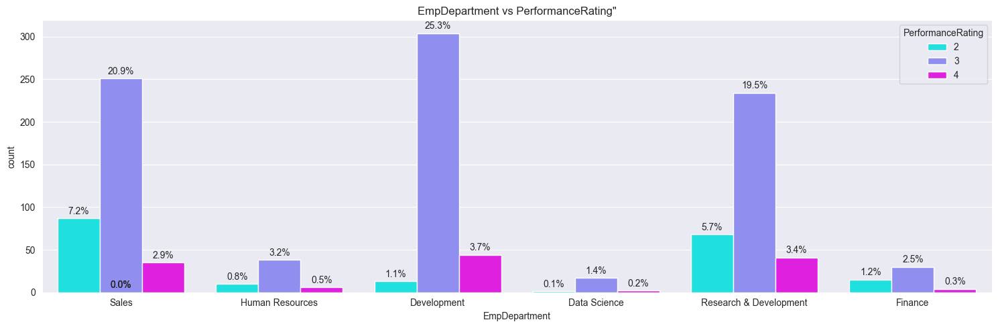

**Insights:**

* Development department dominates the other departments in number.
* In terms of performance rating, employees who belong to development department perform well with the dominating 25% of rating 2.
* Hence departments such as **development, sales and Research & development** constitute the high performing employees.

## **Top 3 factors affecting the employee’s performance:**

From the data analysis and the feature engineering, there are some of the factors which proved crucial in predicting the employee’s performance.

**Among them the top three factors are as factors:**

1. EmpEnvironmentSatisfaction
2. EmpLastSalaryHikePercent
3. EmpDepartment_Development

# **Algorithms used in this project:**

* Decision Tree classifier
* Random Forest classifier
* Support Vector Machine
* Extreme Gradient Boosting

## **Trained models:**

1. **DECISION TREE CLASSIFIER**
2. **TUNED DECISION TREE CLASSIFIER**
3. **RANDOM FOREST CLASSIFIER**
4. **TUNED RANDOM FOREST CLASSIFIER**
5. **SUPPORT VECTOR MACHINE**
6. **TUNED SUPPORT VECTOR CLASSFIER**
7. **TNED XG BOOSTING**

## **Model results:**

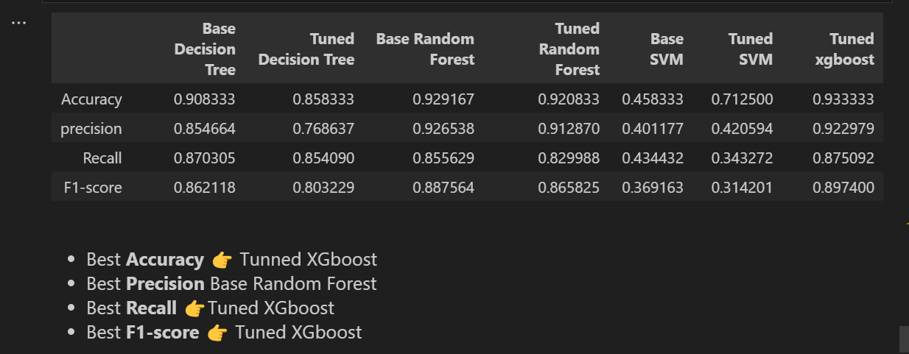

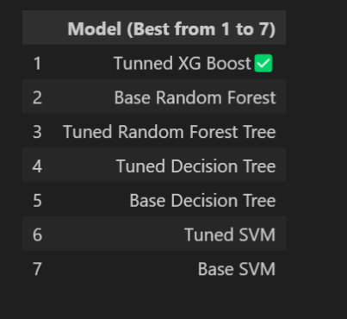

# **RECOMMENDATION:**

## **Model recommendation:**

* The top three would be
  + Tuned XG Boost model
  + Base Random forest model
  + Tuned Random Forest model
* These three models achieved high accuracy scores of range 93 - 90% indicating strong predictive power. However, the choice of the model may depend on other factors, including resource constraints and model interpretability.
* **XG Boost:** Strongly recommended, it’s efficient and highly accurate, but may require fine-tuning.
* **Random Forest:** Recommended if computational resources are available.

## **Recommendations for business problem:**

1. **Timely incentives and recognition**: It's critical to monitor employees' development and ensure that their work receives the proper acknowledgment and a fair raise, as the performance of employees is directly impacted by their wage boost percentage.
2. **Open communication**: Given that the workplace has been shown to have a significant impact on employees' performance ratings, responding to employee concerns in a prompt and caring manner may aid to boost output and productivity.
3. **Creating a welcoming and inclusive work environment**: Better department-wide performance across all job roles should be facilitated by teamwork and collaboration.
4. **Conducting regular performance reviews**: to keep staff members informed of their advancements and to inspire them to make improvements in difficult areas.
5. **Training initiatives**: Timely and relevant skill development programmes

## **CONCLUSION:**

Initiatives that are both logical and compassionate are necessary to raise employee performance. To ensure that appropriate results are expected in a reasonable amount of time, the aforementioned guidelines must be put into practice in a methodical and planned manner. Junior level employees' morale may also be impacted by the top to bottom hierarchy; for this reason, HR partnerships with staff members will be beneficial in finding a decentralised but efficient solution to this problem.